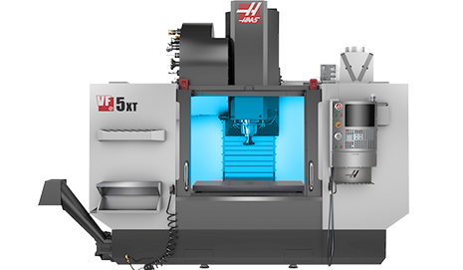HAAS VF5 XT (X=60” TRAVEL, Y=26” TRAVEL, Z=28” TRAVEL, 9.00 ROTARY CENTER HEIGHT, 8100RPM)

HAAS VF4 w/TR200Y – 5 AXIS (X=50” TRAVEL, Y=20” TRAVEL, Z=25” TRAVEL, 10000RPM)

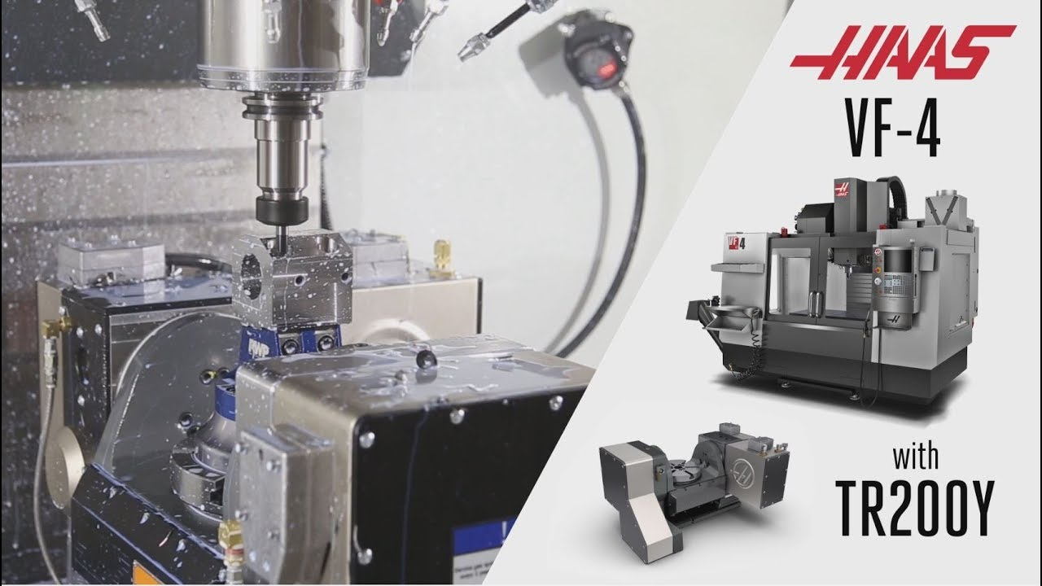

HAAS VF2–4 AXIS(X=30” TRAVEL, Y=16” TRAVEL, Z=20” TRAVEL, 6.00 ROTARY CENTER HEIGHT, 7500RPM)

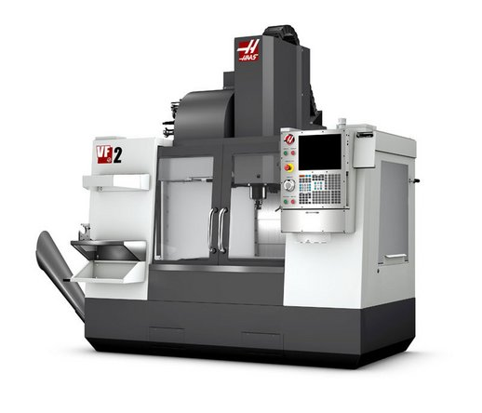

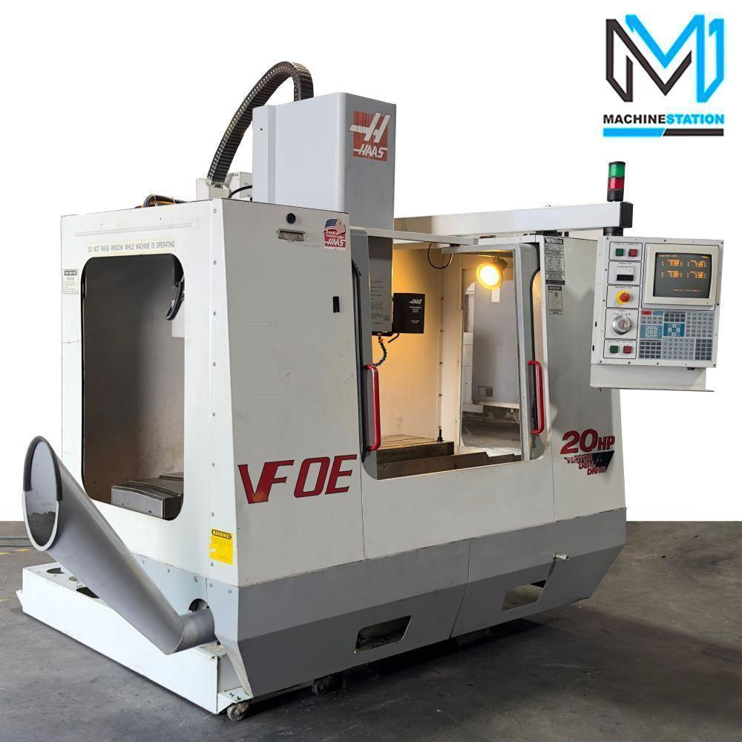HAAS VF0E – 3 AXIS (X=30” TRAVEL, Y=16” TRAVEL, Z=20” TRAVEL)

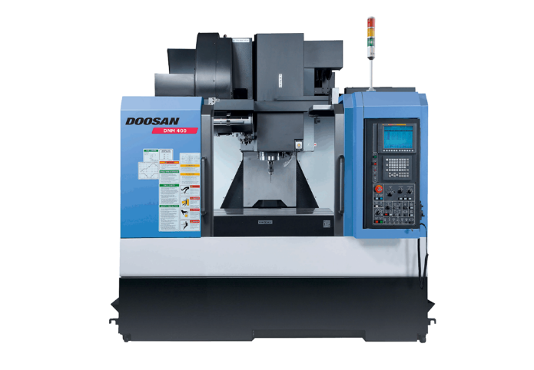DOOSAN DNM400–4 AXIS (X=30” TRAVEL, Y=17” TRAVEL, Z=20” TRAVEL, 5.512 ROTARY CENTER HEIGHT, 8000RPM)

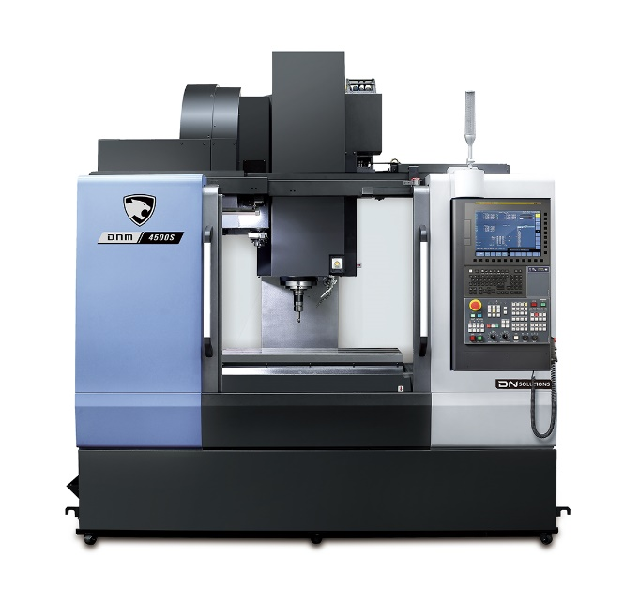DOOSAN DNM4500S – 4 AXIS(X=30” TRAVEL, Y=17” TRAVEL, Z=20” TRAVEL, 6.693 ROTARY CENTER HEIGHT, 15000RPM)

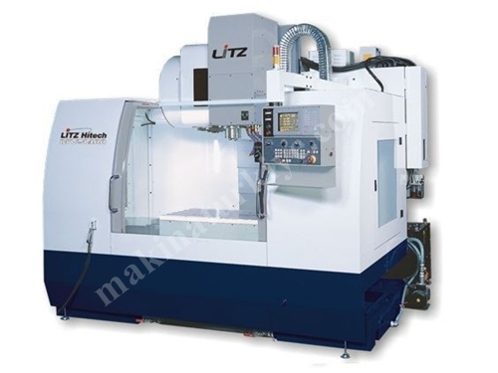LITZ MV1400A – 4 AXIS (X=55” TRAVEL, Y=23” TRAVEL, Z=26” TRAVEL, 8.27 ROTARY CENTER HEIGHT, 8000RPM)

ROBODRILL T14 IE – 3 AXIS (X=19.7” TRAVEL, Y=15.7” TRAVEL, Z=12.9” TRAVEL, 10000RPM)

